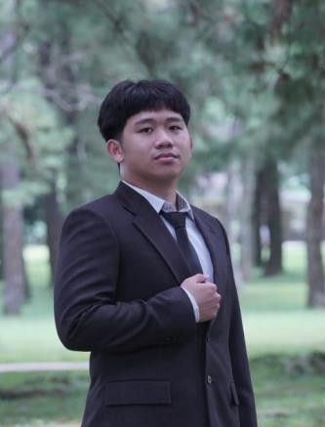
CURRICULUM VITAE (CV)
MY PROFILE
Project Administration professional with hands-on experience in mining construction projects at Kansanshi Mining Plc. Skilled in daily reporting of SMP construction work activities, timesheet administration, manpower planning data compilation, site coordination, camp accommodation management, supporting engineering and project construction administrative tasks.
Procurement & Supply Chain experience as a Procurement Officer at PT Epiterma Mas Indonesia providing end-to-end procurement support for project department needs. Experienced in supplier coordination, purchase order processing, trend tracking, progress monitoring and ensuring timely availability of operational needs, safety PPE etc.
PERSONAL DATA

Name | : | Ronaldo Luiz Walukow
Place & Date of Birth | : | Manado, 9 September 2002
Age: | : | 23 Years Old
Birth Gender | : | Male
Religion | : | Christian
Height | : | 169 Cm
Weight | : | 75 Kg
Address | : | Tomohon City, North Sulawesi, Indonesia
Mobile Phone | : | +62 822 9175 5840
Marital Status | : | Single
Nationality | : | Indonesia
Language | : | Indonesian (Native) English (Professional)
Email | : | walukowronaldo@gmail.com
EDUCATIONAL BACKGROUND

Period | Qualification | Institution | Major
2020 – 2024 | Bachelor’s Degree | Klabat University | Management
2017 – 2020 | Senior High School | St. Nikolaus Tomohon | Social Science
2014 – 2017 | Junior High School | Stella Maris Tomohon | Social Science
2008 – 2014 | Elementary School | SD Inpres Ratatotok | –
ACADEMIC ACHIEVEMENT / CERTIFICATION / RECOGNITION

2023 | : | Completed Odoo Software Certification “Manufacturing Process Professional Module” in cost accounting class
2023 | : | Compiled Standard Operational Procedure of Kobong café
2023 | : | Completed ACCURATE Certification Classes
2023 | : | Completed CAPSIM Business Simulation Certification
2022 | : | Completed Tax Brevet Certification Classes
2020 – 2024 | : | Completed SAP Module HR050, AC010 & SCM600 Certification
2020 - 2021 | : | Member of Student Executive Board (BEM) at Klabat University
2020 - 2021 | : | Public Relation Representative of Student Association
2020 | : | Certified Microsoft Office Specialist with score 935/1000 by Certiport
2020 | : | Certification of Recognition as a Student Executive Board
ABILITIES

Computer Skills | : | SAP, Accurate Professional, CAPSIM, Microsoft Office, Adobe Photoshop, Odoo Software, Lucid Chart, Entrepreneurial Operating System, Pronto Xi
Language Skills | : | Indonesia (Native) and English (active).
Interpersonal Skills | : | Integrity, Good Communication & Teamwork Coordination, Dependability, Flexibility, Adaptability, Problem Solving and Decision Making
Technical Skills | : | Analyse business process, create and develop standard operational procedure. Able to coperate computer well and able to type Tenth Finger fast and accurate. Able to compile a data for strategic / manpower planning
ACADEMIC AND WORKING EXPERIENCES

2021 | : | Completed “Build Your Character” Certification Classes
2022 | : | Business Matching Introduction to Entrepreneurship
2022 | : | Field Study at Klabat University
2023 | : | Worked as an Intern at PT Pertamina Geothermal Energy Lhd in Logistics and Human Capital Department
2024 | : | Worked as a Procurement Officer at PT Epiterma Mas Indonesia in Site Construction Human Resources Department
2025 - Now | : | Currently working as a Project Site Administrator at Kansanshi Mining Site

